Evan Edelstein
EN.605.621.84.FA25
HW 6
The work in this exercise is mine alone without un-cited help. No AI was used to answer these questions.

1) We define the compliment of a language L to be $\overline{L}= {\sum{ }}^{*}-L$, that is all combinations of the symbols in the language except those in L. We would like to show that if $\overline{L}$ is undecidable then L is also undecidable. We say a language is undecidable if there is no algorithms A that accepts (returns 1) all strings (including empty string) in L, and rejects (returns 0) all strings not in L. Note that A always returns a value.
For the sake of contradiction let there be a language L which is decidable but has a compliment that is undecidable. We can construct an algorithm to decide $\overline{L}$ by flipping the answer given by an algorithm that decides L. So, if algorithm A that decides L rejects s in $\overline{L}$ we accept, and if it accepts, we reject. This contradict our assumption that $\overline{L}$ is undecidable. Thus is $\overline{L}$undecidable L is undecidable as well.

2)

$$s^{k}=s concatanating with itself k times$$

Language 1: $L1 = \left\{a^{n}b^{n} \right| 0 ≤n ≤1000\}$
L1 is a finite set of languages composed of n a’s followed by n b’s. Since it is a finite set it can be decided by a finite-state automaton, so it is a regular language and type 3.

Language 2: $L2 = \left\{a^{n}b^{n} \right| n≥0\}$
L2 is like L1, except it is an infinite set. Since it is unbounded and requires that an equal number of b’s follow an equal number of a’s we cannot construct a FSA that determines if a string is in L2. We could use stack of memory to hold the number of a’s and then pop from the stack when a b is seen. In this way we could determine if a string is in the language by ensuring that the stack is empty right after we finish reading the string. Therefore, L2 requires a pushdown automaton (FSA + stack) is as context-free or type2 language.

Language 3: $L3 = \left\{a^{n}b^{m} \right| n, m ≥0\}$
L3 is like L2 but does not require that there are equal number of a’s and b’s so we can represent this language with a finite state automaton that ensures we start at a, a’s transition to a or b and b’s transitions to only b. Therefore, L3 is decided by FSA so it is regular and type 3. A depiction of this FSA is shown below.
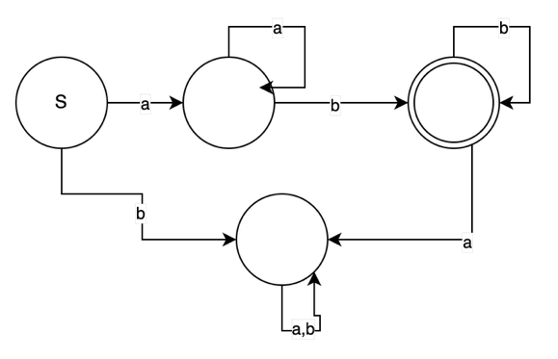
Figure 1: FSA for L3.

3)
a) Since the language provided is finite over all 3 operations, we can construct a FSA that can represent this language and decide if an input is in it. Therefore, it is a regular language and type 3.

b) It will always halt since there are no infinite or recursive rules generated by the 3 operations. Each operation only expands the language by a finite number of non-terminal states. (also it says it will always accept or reject an input in the questions).

c) We can decompose the 3 wildcard operations into a form only using the 3 basic operations. A ‘.’ can be rewritten as the concatenation of a, an alternation of all the single letter symbols, and c.
$a.c→a \left( a U b U c…\right) c$
The ‘*’ wildcard expression a*c can be written as the concatenation of a, $Σ^{*}$and c, since $Σ^{*}$ includes the empty string as well.
$$a*c→a∑^{*}c$$
The a{m.n}c matching can be rewritten by alternating all the Kleene stars of {a} up to from m to n times.
$$a\left\{m,n\right\}c→\left(a U aa…\right)c$$

d)

Citations:
[1] https://www.youtube.com/watch?v=p1peR1Qbp0s&list=PL1BaGV1cIH4WFbOgfefWr3nXCEIeqp6br&index=5

